What is Graphx
What are component of Graphx
Use case of Graphx
Hands on Code

>>>What is Graphx

GraphX is a graph processing library in Apache Spark

>>>What are components of Graphx

1. Vertices—-Vertices are entities or objects in a graph
2. Edges—--Edges represent relationship between vertices
3. Triplets—---Triplet = Vertex + Edge + Vertex(it combines Source vertex
Edge , Destination vertex)

>>>>Use case of Graphx:
GraphX is mainly used where relationships between data are important, not just rows and columns

→ Social Network Analysis(connecting friends on instagram,facebook)
→Recommendation Systems(when we buy , one kind of product it also suggest other)
→ Fraud Detection (Banking / Payments)
→ Web Page Ranking (Google Concept)

>>>Hands on code

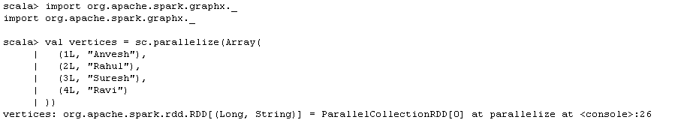
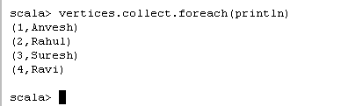

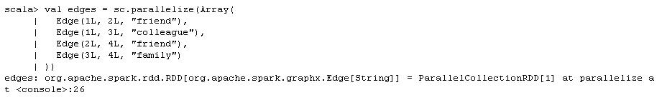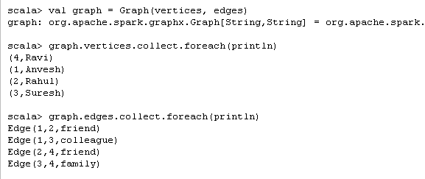

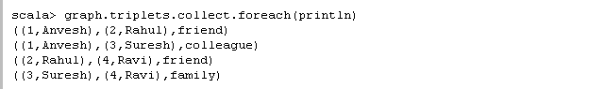

Streaming in Spark

Messaging tool

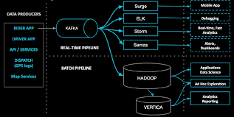

How do You design Data Pipeline

What are the components of Kafka

>>Producer
>>consumer
>zoo keeper
>kafka Server

